Ex No: 7a) Configuration of HyperV on Windows of VMs
Date:

Aim:
To configure Hyper-V on Windows for creating and managing virtual machines (VMs), enabling efficient virtualization and resource utilization.
Steps:
- Click Turn Windows features on or off.
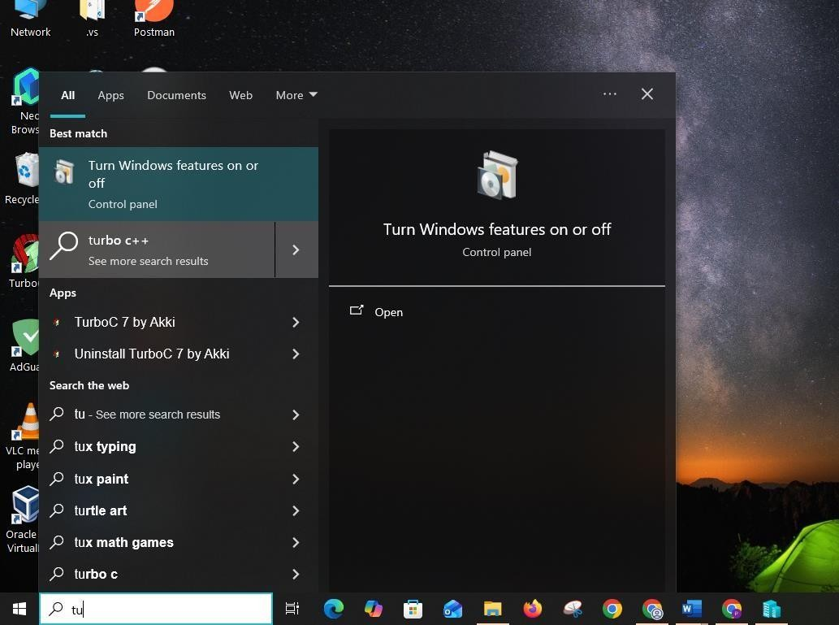
- Find Hyper-V select all hyper -V and restart
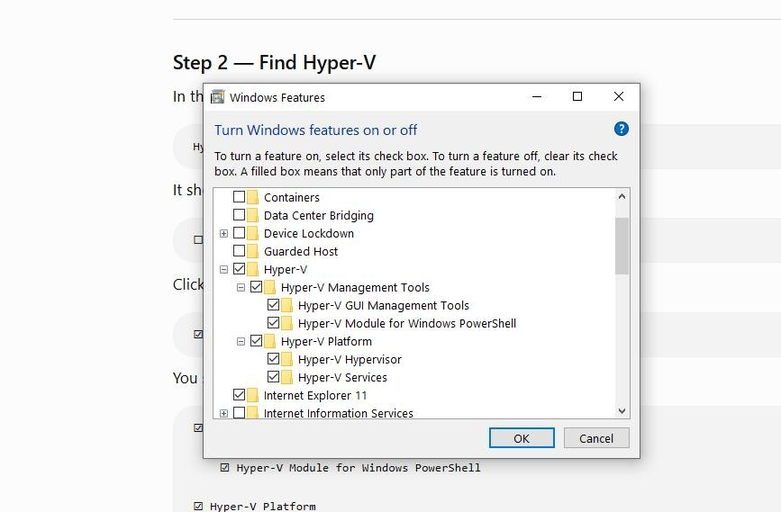

- After your PC restarts Press the Windows key and search: Hyper-V Manager
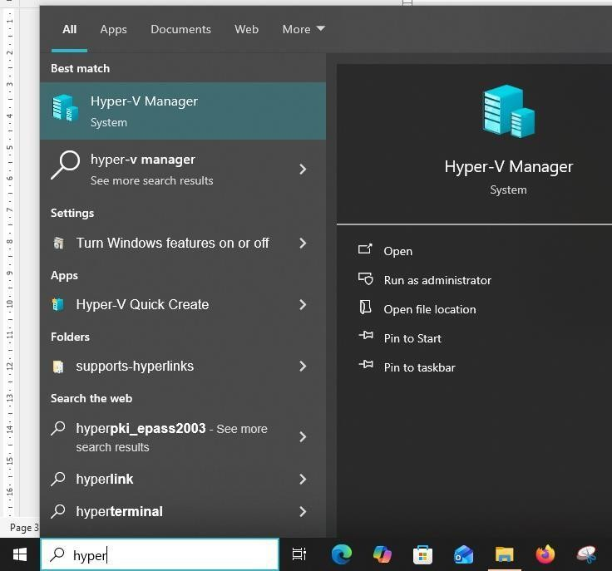

Step 4: The HyperVisor Manager will open
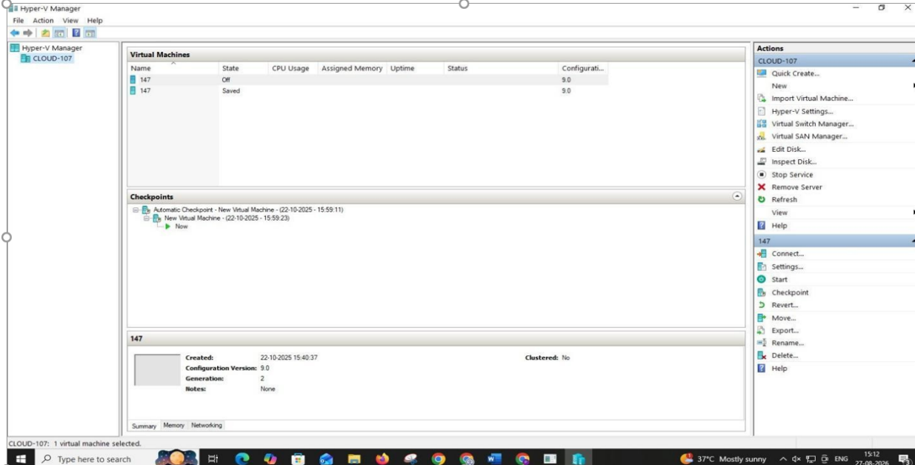

RESULT: Thus the configuration Hyper-V on Windows for creating and managing virtual machines (VMs), enabling efficient virtualization and resource utilization has been executed successfully
Ex No: 7b) Creation of VM, Powershell commands, Management
Date:

Aim:
To create and manage Virtual Machines (VMs) using Hyper-V, including PowerShell commands for automation and efficient administration.
Procedure:
(Vm installation without powershell)
1)open Tools-> hyper v manager-> right click on server and click create new vm
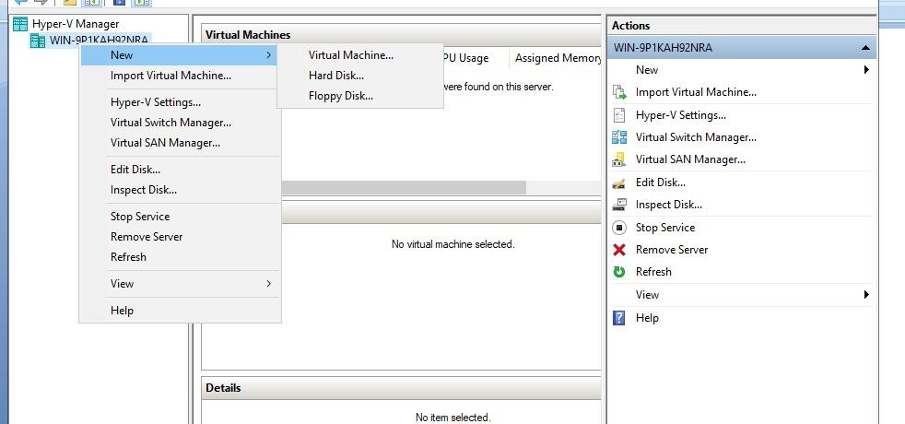
2)Specify name and location click next.
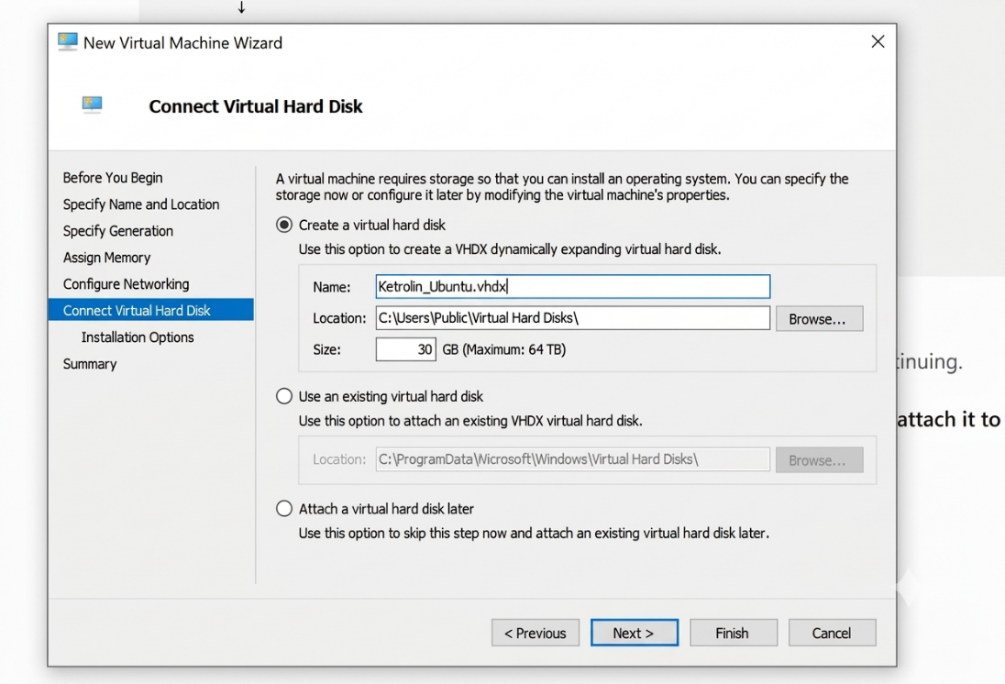

3. Now Specify generation 2
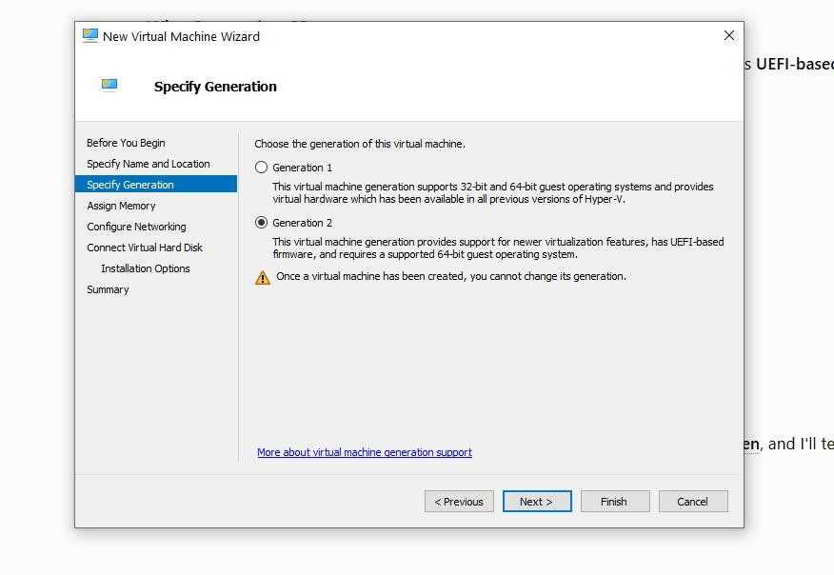
3)Assign the memory for the vm(for safety give as 2gb )
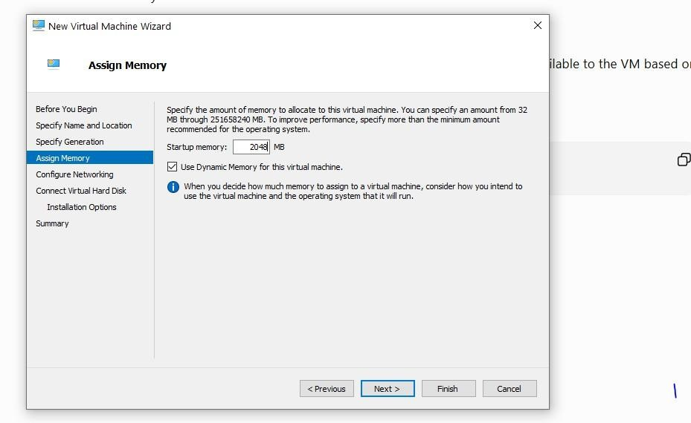

4)Conigure the network click on Default Switch
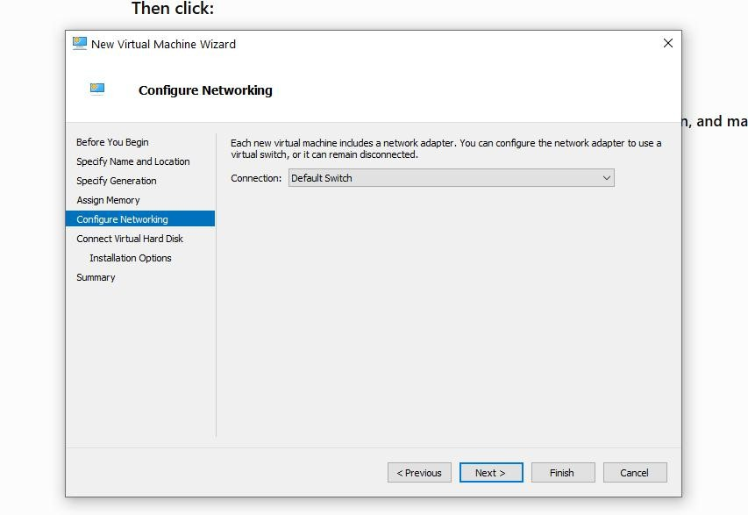
5)Connect virtual harddisk click next
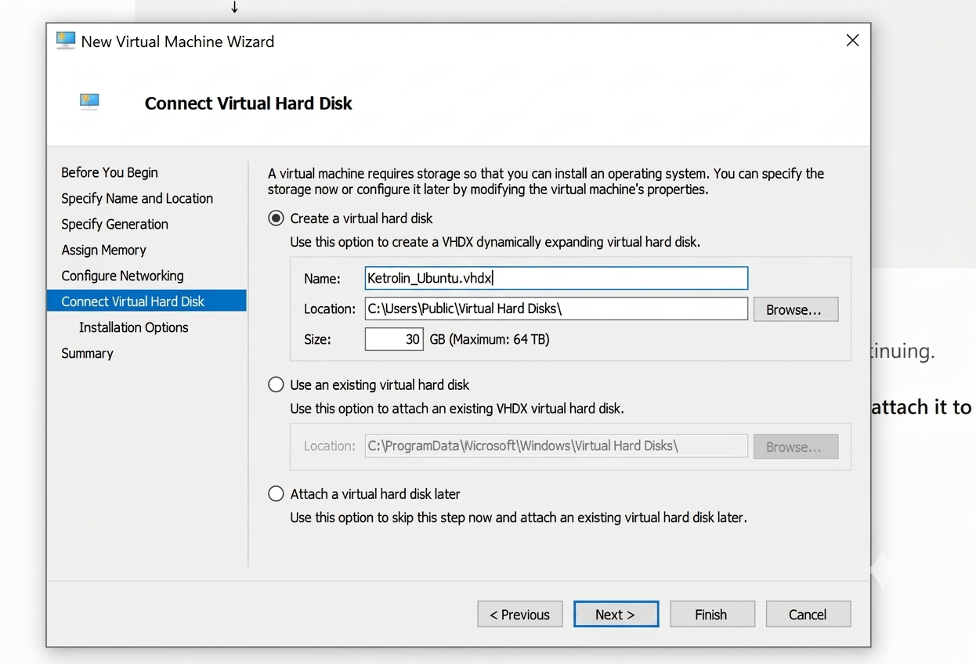

6)Import the iso file which os need to install on the vm(here ubunttu)
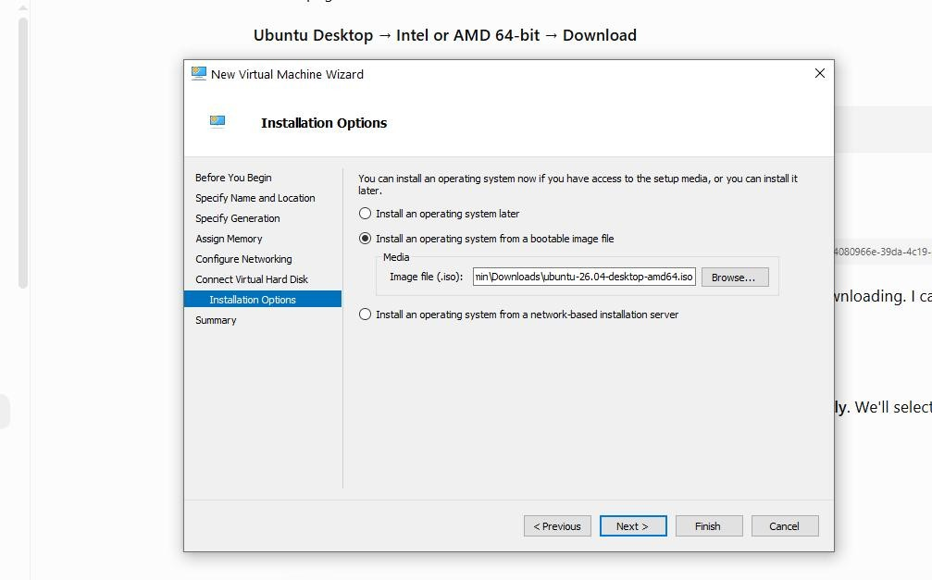
7)Click finish

- Change the Security setting - Change Template to MicrosoftUEFI
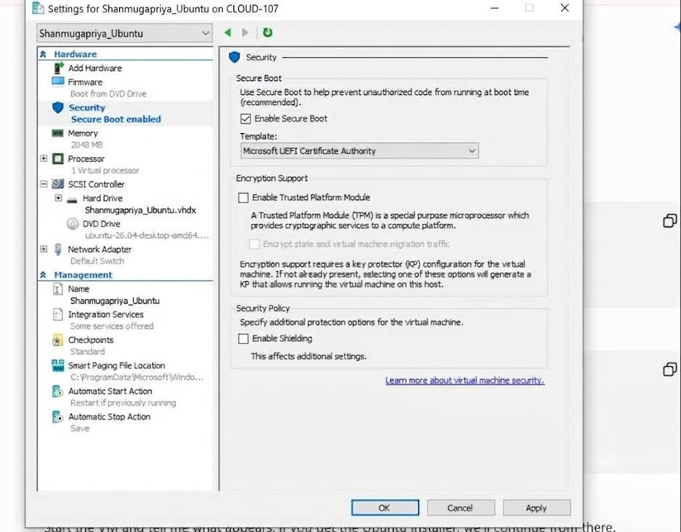
- we can start the the vm in hyper-V manager by using connect option in the right panel after starting the VM
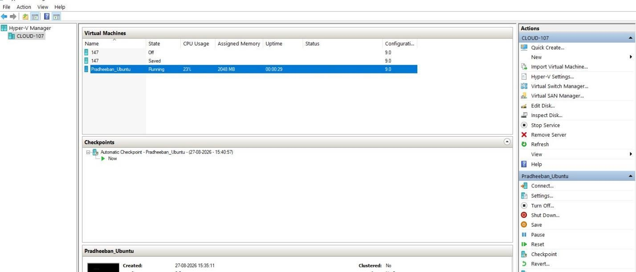
10)Once the VM starts it ask for setup and follow the steps in the screenshots :
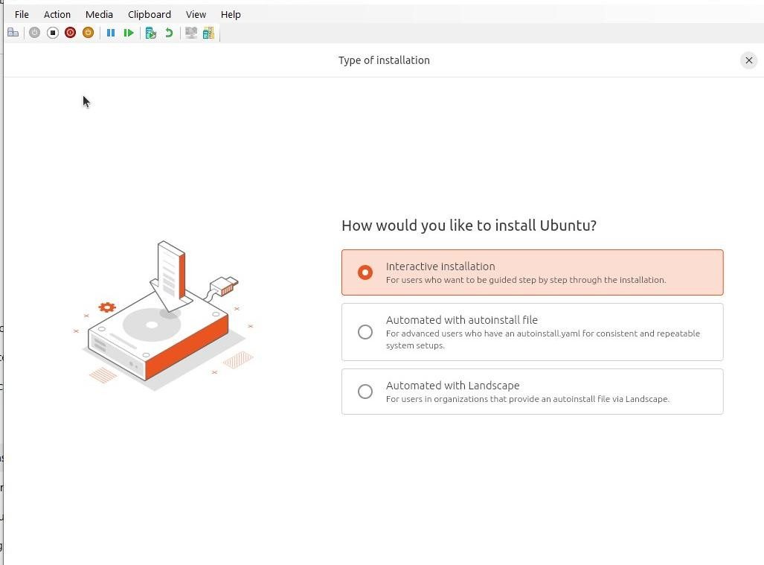
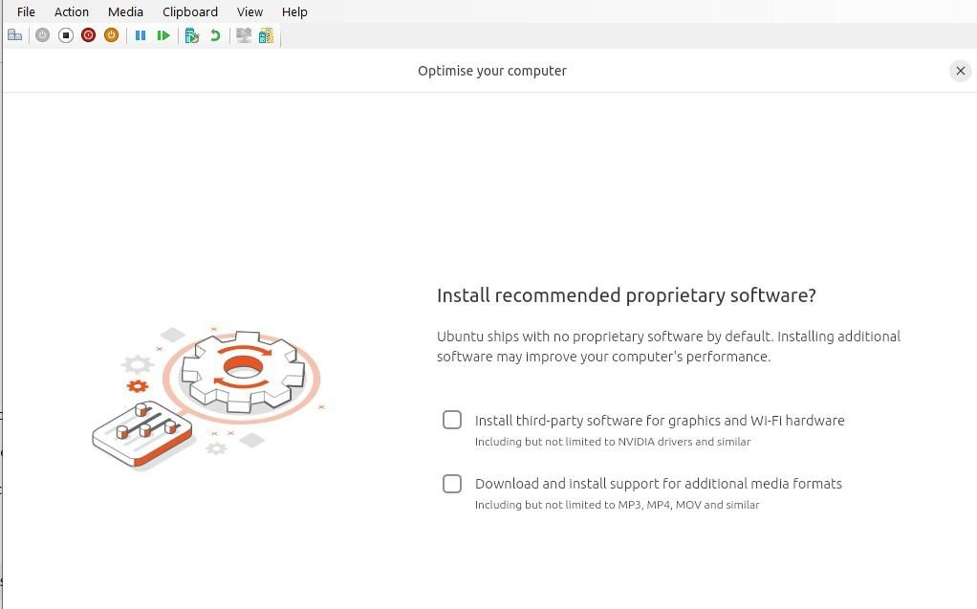
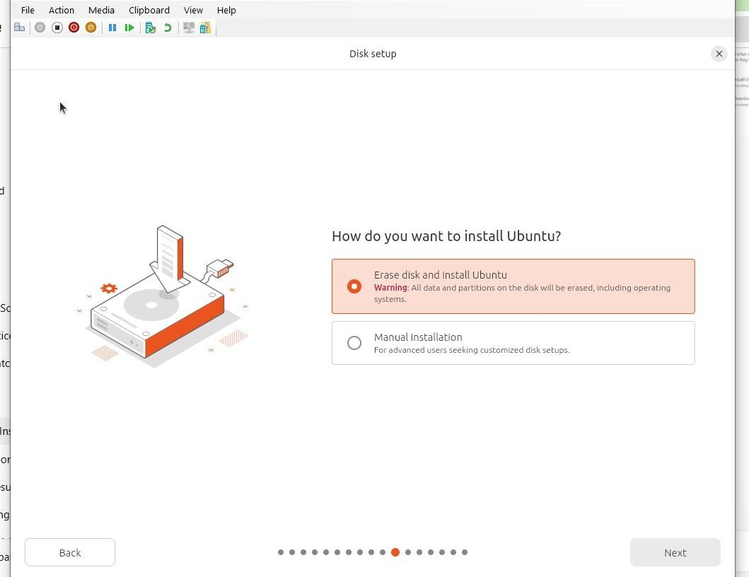
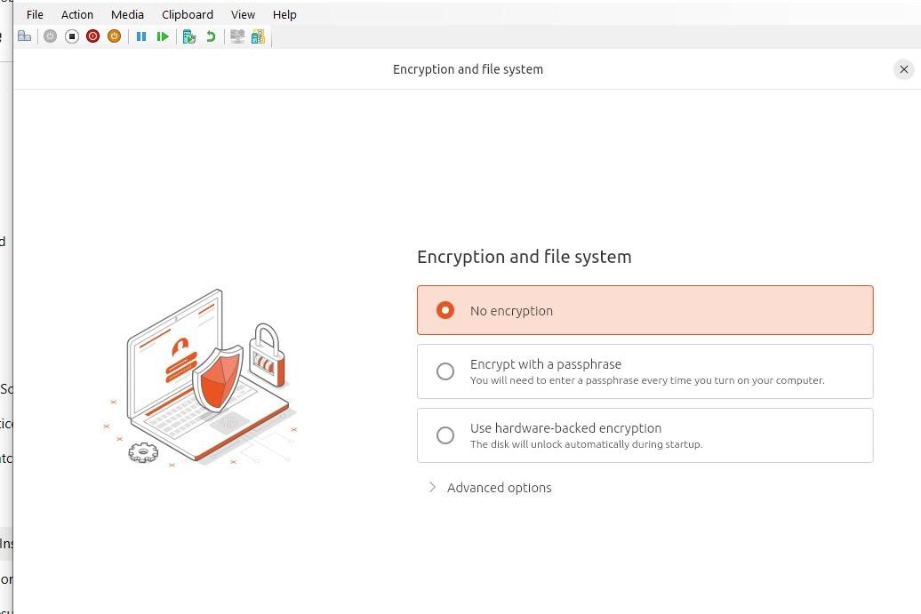
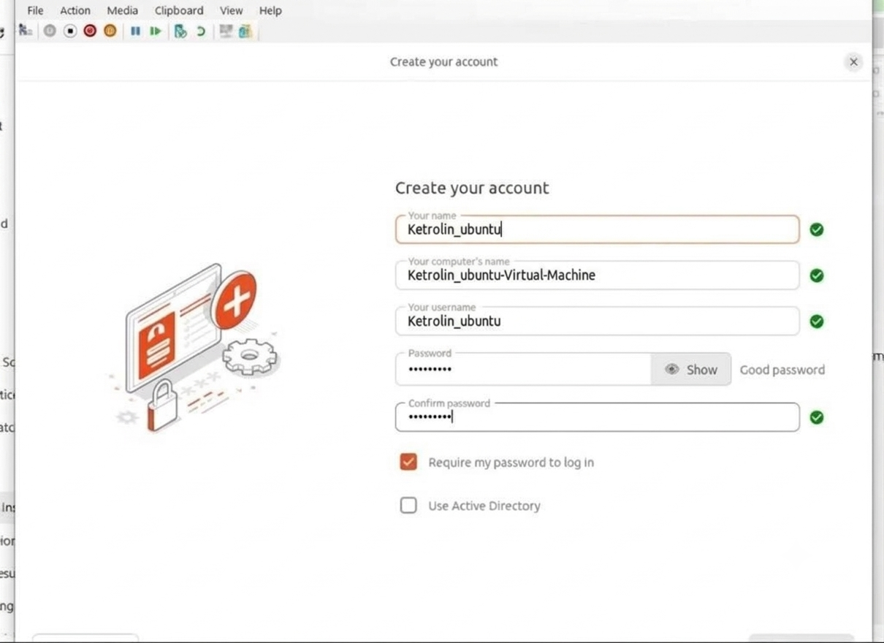
After finishing all the steps it will start to install and it will ask to restart after restarting the ubuntu screen will appear
Vm installation using Powershell Procedure :
Get-VMSwitch
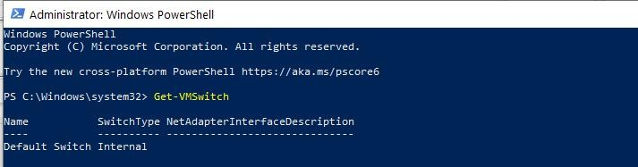
1) Create vm with name and space in gb with virtual hard disk creation
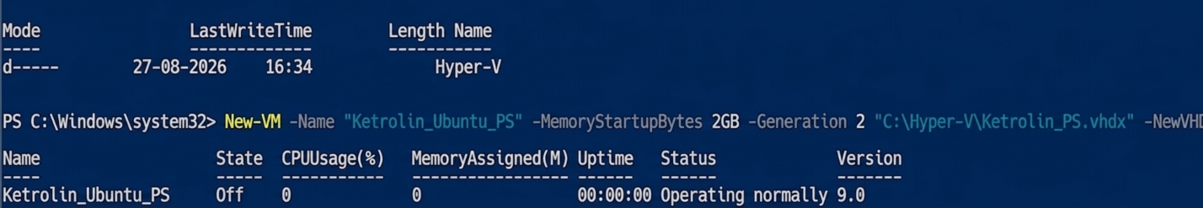
2)Asssign virtual switch to the vm give the switch as we already got in the get switch command
3)import the iso file which os need to install on vm
4)Start the vm
We can check the status
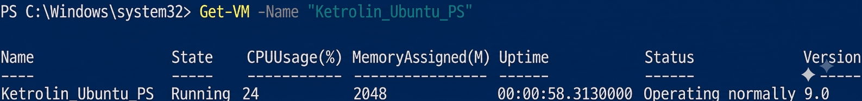
5) If you want to start the VM go to Hyper visor manager you can see the created VM now you can connect to the VM
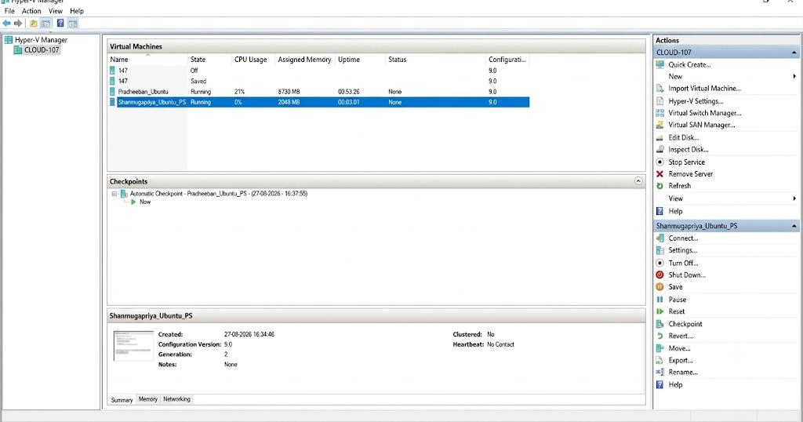
Powershell commands
1)To see the status of VM and Stop the VM

Migration :
Right click the vm and click move and follow the steps .
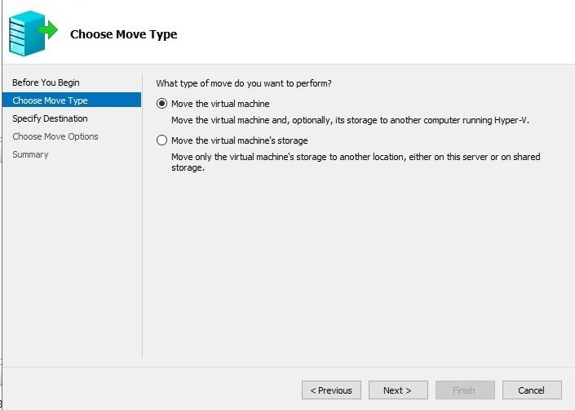
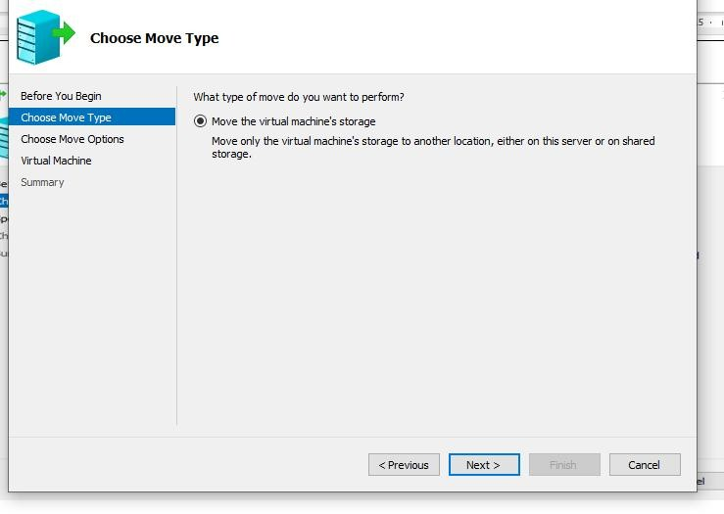
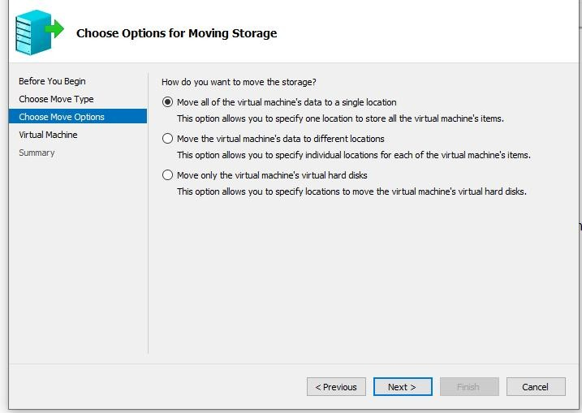
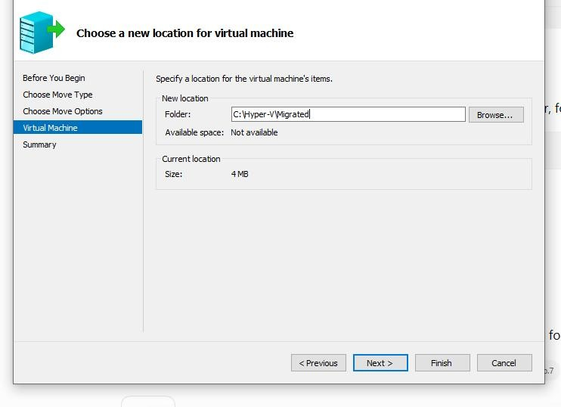
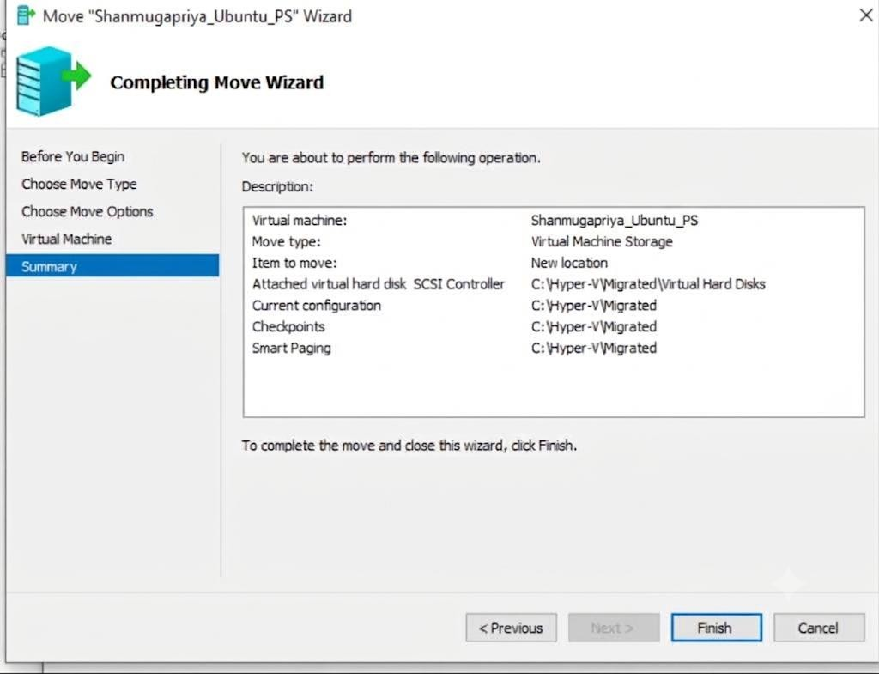
The VM is Succesfully moved
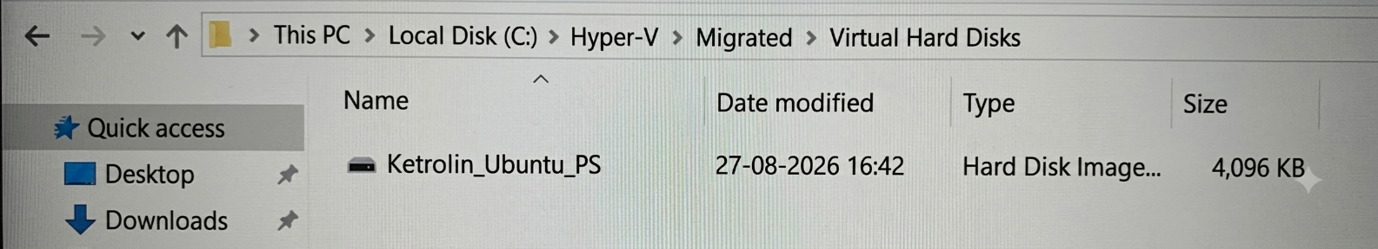
Result:
Thus the creation and manage Virtual Machines (VMs) using Hyper-V, including PowerShell commands for automation and efficient administration has been executed successfully.

